

**Systems Engineering and Engineering Management Department**

**EMGT 6952 Engineering Optimization**

**Submitted by**

Dishant Banga

Rojan Bhattarai

Joseph Carson

Term Project Report

On

Distribution problem

***Executive Summary***

This project talks about the Distribution problem of a company which has 2 factories one at Atlanta and one at Charlotte. Moreover, it has four ware houses at Birmingham, Greenville, Gastonia, and Augusta. There are six major customers for the company C1, C2, C3, C4, C5 and C6. Some customers have preferences for the product source. i.e. Some customers prefer being supplied directly from factories and others prefer being supplied from a certain warehouse. The monthly production capacity of factories and throughput capacity of warehouse is provided. Also, the monthly requirement of the customers are given, along with the cost of distribution from factory to customer, from factory to warehouse and from warehouse to customer. The objective for part I of the problem is to minimize the overall distribution cost subjected to constraints related to factory and warehouse capacity, customer demand and customer preferences. For this part of the project, two different models one without customer preferences and second one with customer preferences is developed. When the preference of the customer is considered, it is assumed that only the preferred route is available to reach to the customer and have less decision variables compared to the other model. The transportation cost is going to go higher when the customer preference is taken into consideration as preferred route from customers are not necessarily cost effective route. The solution is obtained using Excel Solver and MATLAB’s linear programming solver. On comparing the solution from MATLAB with Excel, it was observed that multiple distribution pattern exists for this problem that satisfies the customer demand without affecting the overall cost. The effect of change in the factory capacity, warehouse capacity, customer demand and the transportation cost were studied based on the sensitivity analysis report provided from Excel Solver. The analysis of the results are provided in the corresponding section of the report.

The second part of the problem talks about the decision of setting up of two new warehouses at location Knoxville and Asheville, as well as an option to expand the Greenville warehouse. For this the setup cost and the saving cost related to respective warehouses has been given along with the distribution cost. A MIP model is designed without considering the customer preferences, and to make the decisions related to setting and enlarging of warehouses binary variables has been used along with other constraints. The solution of this model comes to the decision that Birmingham warehouse should be closed, Greenville warehouse should not be expanded, Knoxville warehouse should not be built, Augusta warehouse is not closed and Asheville warehouse is to be built.

**Introduction:**

The optimization objective in this problem is to determine the distribution pattern of product of a company which are developed in its two factories, and which can be distributed to six of its customers directly or through four of the warehouses with storage facilities. There is a constraint related to the production capacity of the factories, product handling capacity of the warehouses, and customer demand and customer preferences. The cost of transfer of the product of one location to other is also provided. The decision variables chosen in the problem is in the *xAB* , which represents the total units of the product being transferred from location A to location B. The list of the decision variable designed for the problem is then modified the following form for ease of identification in programming:

Table 1: List of decision variables used in the Optimization Problem

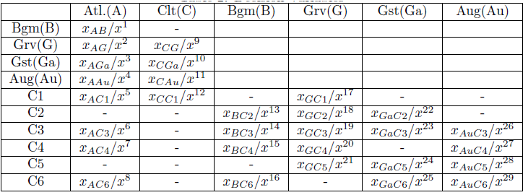

1. **What distribution pattern would minimize overall cost?**

Based on the variables mentioned above the objective function determined for the problem is in the form of:



which is subjected to:

1. Inequality Constraints
2. Factory Production Constraints
3. Warehouse throughput constraints
4. Equality Constraints
5. Warehouse input output balance
6. Consumer demand requirement
7. Non-negativity constraints for the variable

The distribution pattern that would minimize the overall cost is shown in figure 1 below.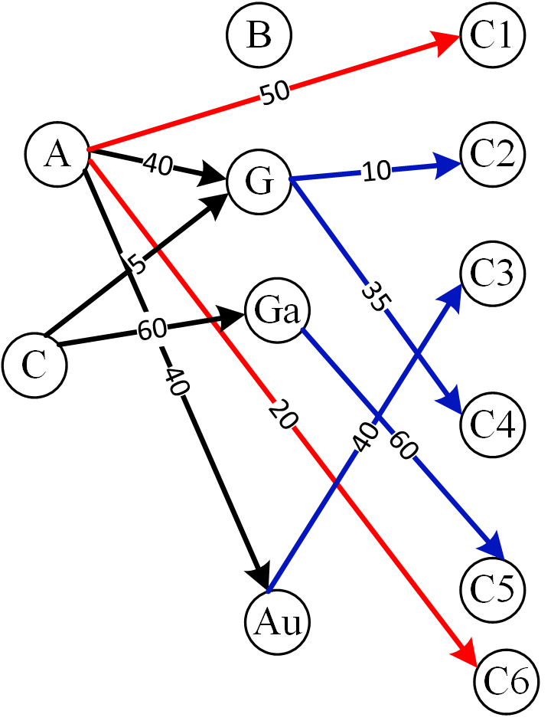

Figure 1. Distribution Pattern that would minimize the overall cost (when consumer preference not considered).

And, the minimum cost is $31,700,000.

**2. What the effect of increasing factory and warehouse capacities would be on distribution costs?**

Since in both the preferred case and in the case where the preference is not considered, the factory capacity at the Charlotte factory is within the limits i.e.≤200,000, increasing the production capacity at Charlotte would have no effect on the overall distribution cost.

For case where no consumer preference is considered, it can be observed that the factory at Atlanta is utilized to its limit of 150,000 tons. Intuitively, it seems like increasing the capacity of Atlanta factory would change the distribution costs. However, this increment on Atlanta's factory capacity does not change the distribution cost as delivering to Greenville from either Charlotte/Atlanta costs the same price and delivering to Gastonia is cheaper from Charlotte when compared to Atlanta, so it does not intuitively feel that increase in the production capacity of Atlanta Factory would change in the distribution cost.

In both the cases, it can be observed that the warehouse at Augusta is increased to its full limits, with this it is necessary to examine the effect of expansion of the warehouse at Augusta has on the overall distribution costs. However, it should also be noted that Augusta is the cheapest option to deliver to consumer C3 only (for C5, it matches with Greenville and Gastonia) and as the optimal solution has consumer C3's demand met from Augusta warehouse alone, until the demand in consumer C3 increases, increment in warehouse capacity at Augusta would have no impact on the distribution cost.

In the case with consumer preference considered, it can be observed that consumer C5 is limited to getting the products from the desired location because of the limitation of warehouse at Greenville. As, the warehouse at Greenville is increased in its capacity, the price of the distribution cost increases.

**3. What the effects of small changes in costs, capacities and requirements would be on the distribution pattern?**

The cost related to variables x1 through x23 can be changed in the following range without affecting the optimal cost function.

Table 2: Table showing the allowed changes in the distribution cost without affecting the optimal cost.

|  |  |  |
| --- | --- | --- |
| Variables | Reduction in Cost Allowed without changing optimal solution | Increment in Cost Allowed without changing optimal solution |
| X1 | 0 | 0 |
| X2 | 0 | 1E+30 |
| X3 | 90 | 1E+30 |
| X4 | 1E+30 | 0 |
| X5 | 1E+30 | 1E+30 |
| X6 | 80 | 1E+30 |
| X7 | 80 | 0 |
| X8 | 1E+30 | 0 |
| X9 | 190 | 90 |
| X10 | 0 | 1E+30 |
| X11 | 1E+30 | 1E+30 |
| X12 | 40 | 80 |
| X13 | 0 | 1E+30 |
| X14 | 80 | 1E+30 |
| X15 | 1E+30 | 80 |
| X16 | 1E+30 | 1E+30 |
| X17 | 190 | 1E+30 |
| X18 | 1E+30 | 90 |
| X19 | 1E+30 | 90 |
| X20 | 1E+30 | 40 |
| X21 | 40 | 1E+30 |
| X22 | 90 | 1E+30 |
| X23 | 90 | 1E+30 |

As warehouse in Birmingham and Gastonia are under utilized , the constraint related to them are non-binding so increasing their capacity has no impact on the distribution pattern. However, as Greenville and Augusta are utilized to their limits the changes in their capacity will have an impact on the distribution cost.

Table 3: Table showing the type of constraint related to factory and warehouse capacity aloong with the slack available.

|  |  |  |
| --- | --- | --- |
| Constraint | Type | Slack |
| Atlanta Production Constraint | Not Binding | 15000 |
| Charlotte Production Constraint | Not Binding | 120000 |
| Birmingham Throughput Constraint | Not Binding | 60000 |
| Greenville Throughput Constraint | Binding | 0 |
| Gastonia Throughput Constraint | Not Binding | 70000 |
| Augusta Throughput Constraint | Binding | 0 |

**4. Would it be possible to meet all customer preferences regarding suppliers, and if so what would the extra cost of doing this be?**

It was observed that not all the customer preference regarding suppliers was met (in the initial solution), the extra cost incurred to meet the preference requirement is $ 9,000,000. Also, note that it is impossible to met the demand of customer C5 from its preferred location of Greenville as C5 demands 60,000 items but Greenville only has a throughput capacity of 50,000. The distribution pattern when the consumer preference is honored is shown in figure 2 below.

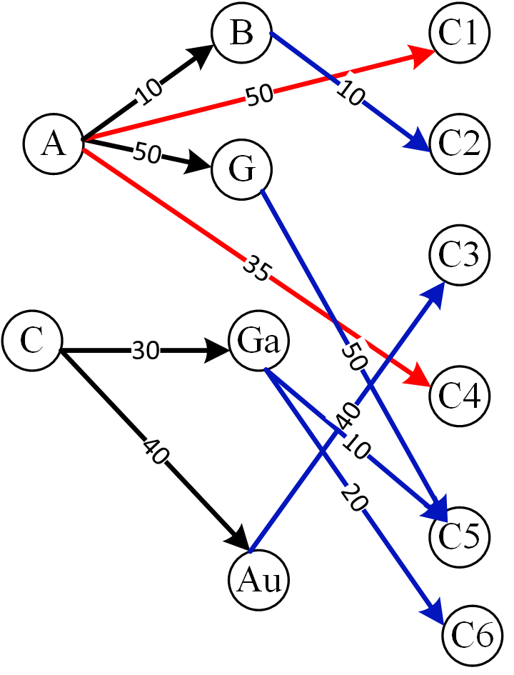

Figure 2: Optimal Distribution Pattern when the consumer preference is honored.

**Project Question 2:**

**Which new warehouses should be built? Should Greenville be expanded? Should Birmingham or Augusta be closed down? What would be the best resultant distribution pattern to minimize overall costs?**

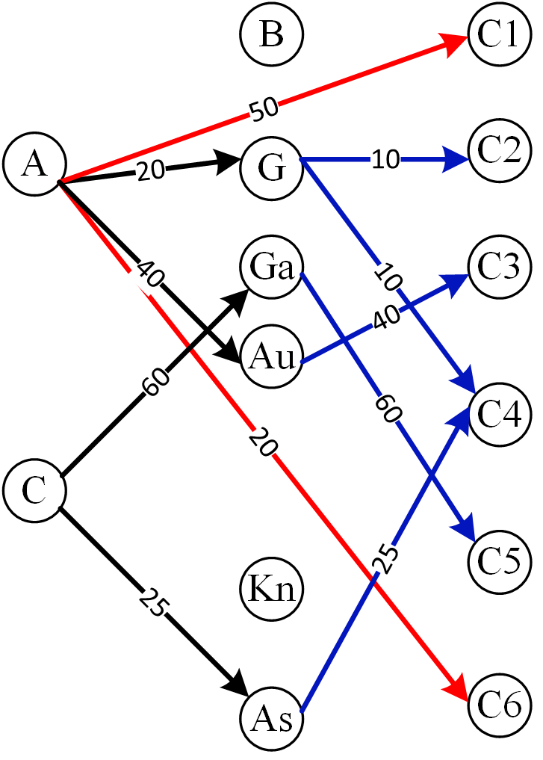

Figure 3: Optimal Distribution Pattern with the new constraints (consumer preference is not honored).

New warehouse should be built in Asheville. The Greenville warehouse need not be expanded. Birmingham warehouse needs to be closed down. And the best resultant distribution is shown in Figure 3.

**Conclusion:**

To conclude in this project, an optimal distribution pattern was found for product distribution of a company. It was observed that multiple optimal solution path can exist. The analysis related to whether new warehouses should be built or not based on the corresponding prices were also analysed.